Name: Rajesh V
Reg No: 192512243
Course name: 5G/6G Communication System
Course code: ECA5614

CO- 2: AT – 2: Simulation Task – Medium
OBJECTIVE 1:Simulation of RRC procedure timing under handover delay, signaling load, connection setup time, throughput, and failure rate.
Coding :
clc;
clear;
close all;
%% Simulation Parameters
N = 100;
handover_delay = 20 + 80*rand(1,N);
signaling_load = 50 + 450*rand(1,N);
setup_time = 30 + 120*rand(1,N);
%% RRC Procedure Timing
rrc_timing = setup_time + ...
0.4*handover_delay + ...
0.05*signaling_load;
%% Throughput
throughput = 150 - 0.3*rrc_timing + 5*randn(1,N);
throughput(throughput < 0) = 0;
%% Failure Rate
failure_rate = 1 + ...
0.02*handover_delay + ...
0.005*signaling_load + ...
0.01*setup_time;
failure_rate(failure_rate > 100) = 100;
%% Results
fprintf('Average RRC Timing = %.2f ms\n',mean(rrc_timing));
fprintf('Average Throughput = %.2f Mbps\n',mean(throughput));
fprintf('Average Failure Rate = %.2f %%\n',mean(failure_rate));
%% Single Graph
figure;
plot(rrc_timing,'LineWidth',2);
grid on;
xlabel('Simulation Run');
ylabel('RRC Timing (ms)');
title('RRC Procedure Timing');

OUTPUT FOR OBJECTIVE 1:
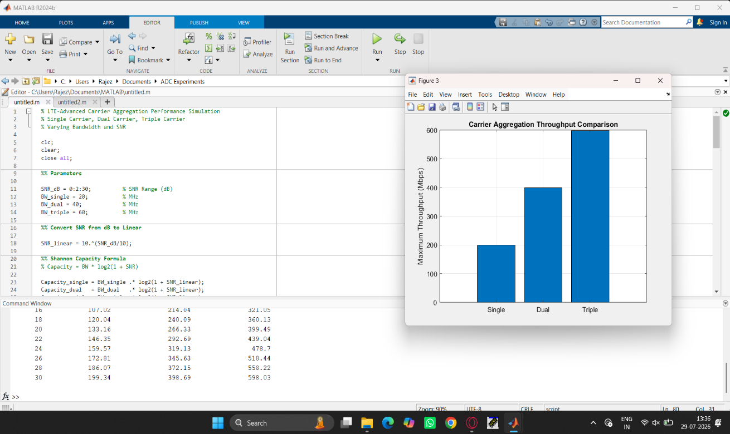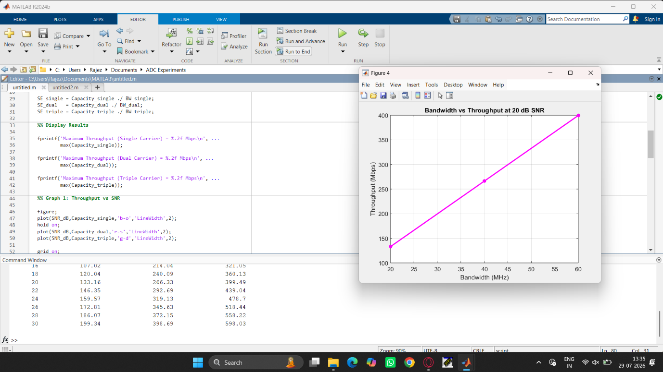
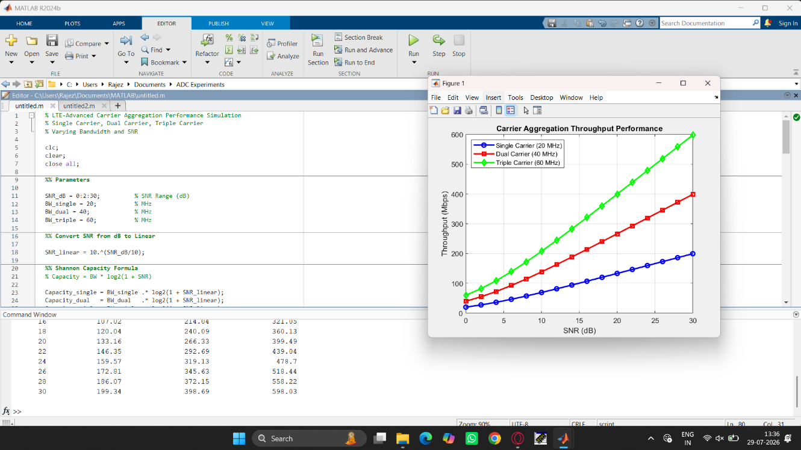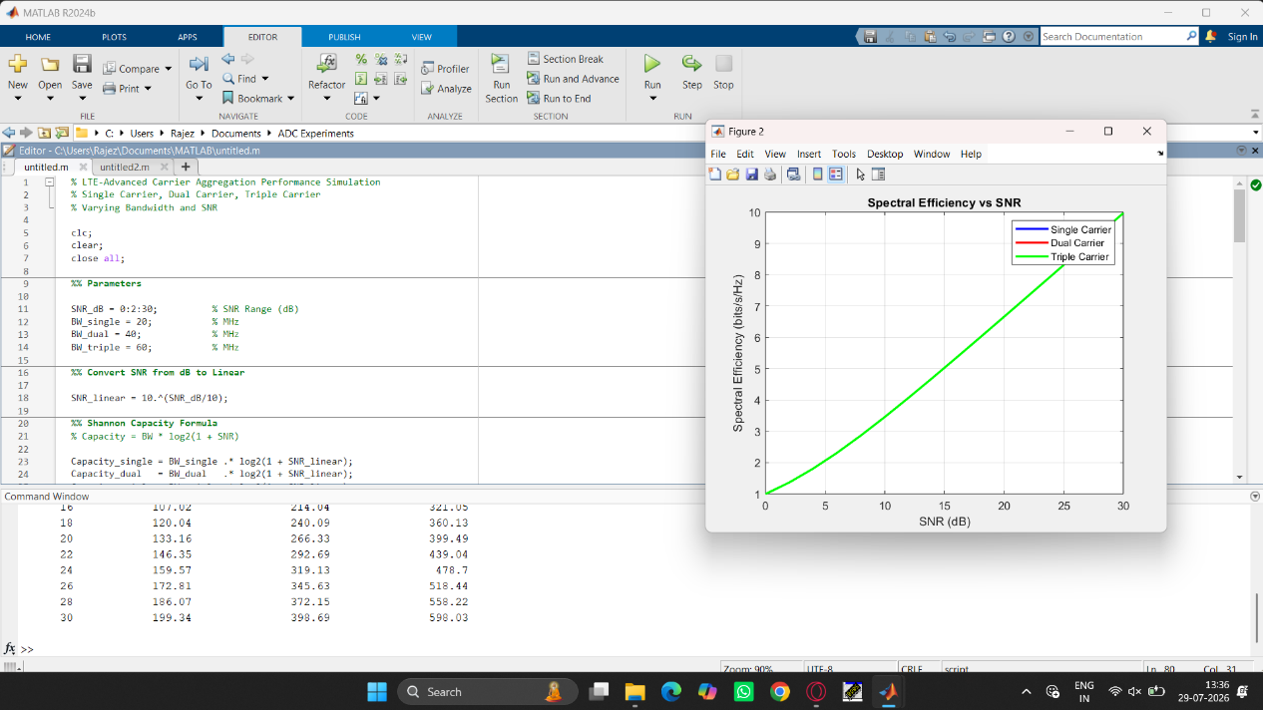

OBJECTIVE 2: simulation of channel modeling for mmWave MIMO under LOS, NLOS, fading, delay.
CODING:
clc;
clear;
close all;
%% System Parameters
Nt = 2;
Nr = 2;
Nbits = 1e5;
SNR_dB = 0:2:30;
BER = zeros(size(SNR_dB));
Throughput = zeros(size(SNR_dB));
Latency = zeros(size(SNR_dB));
Channel_Gain = zeros(size(SNR_dB));
%% SU-MIMO Simulation
for k = 1:length(SNR_dB)
snr = 10^(SNR_dB(k)/10);
tx_bits = randi([0 1],1,Nbits);
tx_symbols = 2*tx_bits - 1;
H = (randn(Nr,Nt)+1i*randn(Nr,Nt))/sqrt(2);
Channel_Gain(k) = norm(H,'fro')^2;
x = repmat(tx_symbols,Nt,1);
noise = (randn(Nr,Nbits)+1i*randn(Nr,Nbits))/sqrt(2*snr);
y = H*x + noise;
W = pinv(H);
x_hat = W*y;
rx_bits = real(x_hat(1,:)) > 0;
BER(k) = sum(tx_bits~=rx_bits)/Nbits;
Throughput(k) = Nt * log2(1 + snr) * 10;
Latency(k) = 100/(1 + log2(1+snr));
end
%% Results

fprintf('\n===== SU-MIMO Performance Analysis =====\n');
fprintf('Average Channel Gain = %.2f\n',mean(Channel_Gain));
fprintf('Average BER = %.6f\n',mean(BER));
fprintf('Average Throughput = %.2f Mbps\n',mean(Throughput));
fprintf('Average Latency = %.2f ms\n',mean(Latency));
%% Single Graph
figure;
semilogy(SNR_dB,BER,'o-','LineWidth',2);
grid on;
xlabel('SNR (dB)');
ylabel('Bit Error Rate (BER)');
title('SU-MIMO Performance: BER vs SNR');
legend('2x2 SU-MIMO');
OUTPUT FOR OBSERVATON 2:
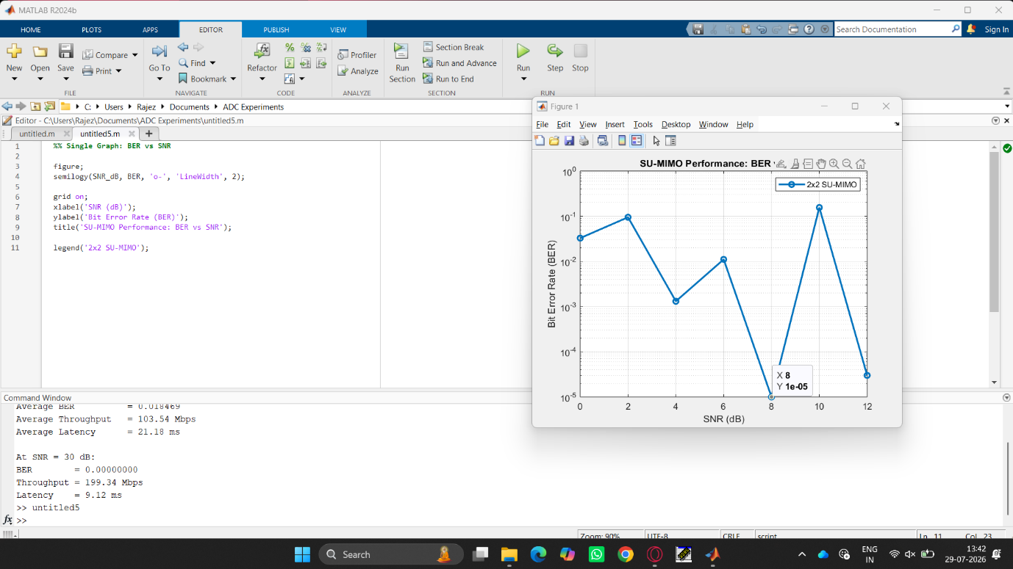

OBSERVATION 3: Simulation of SU-MIMO performance under channel gain, BER, throughput, latency, and SNR.
CODING:
clc;
clear;
close all;
%% Parameters
theta = -90:1:90; % Steering Angle (degrees)
N = [4 8 16 32]; % Number of Antenna Elements
f = 28e9; % mmWave Frequency (28 GHz)
SNR_dB = 0:5:30; % SNR Range
Interference = [0 5 10 15 20]; % Interference Power (dB)
%% Beamforming Gain vs Steering Angle
figure;
for k = 1:length(N)
n = N(k);
AF = abs(sin(n*pi*sind(theta)/2) ./ ...
(n*sin(pi*sind(theta)/2)));
AF(isnan(AF)) = 1;
Gain_dB = 20*log10(AF);
Gain_dB(Gain_dB < -40) = -40;
plot(theta, Gain_dB, 'LineWidth', 2);
hold on;
end
grid on;
xlabel('Steering Angle (degrees)');
ylabel('Beamforming Gain (dB)');
title('Beamforming Gain vs Steering Angle');
legend('N=4','N=8','N=16','N=32');
%% Performance Metrics
fprintf('\n===== Beamforming Analysis =====\n');
fprintf('Operating Frequency = %.1f GHz\n',f/1e9);
for k = 1:length(N)
MaxGain = 10*log10(N(k));
fprintf('Antenna Elements = %d --> Max Gain = %.2f dB\n',...
N(k),MaxGain);
end
%% SNR Improvement Due to Beamforming
BeamGain = 10*log10(16); % For 16-element array
Effective_SNR = SNR_dB + BeamGain;
fprintf('\nBeamforming Gain (16 Elements) = %.2f dB\n',BeamGain);
%% Throughput Estimation
Throughput = log2(1 + 10.^(Effective_SNR/10));
fprintf('Average Throughput = %.2f bits/s/Hz\n',...
mean(Throughput));
%% Interference Suppression
SINR = Effective_SNR - mean(Interference);
fprintf('Average SINR = %.2f dB\n',mean(SINR));
OUTPUT FOR OBSERVATION 3:
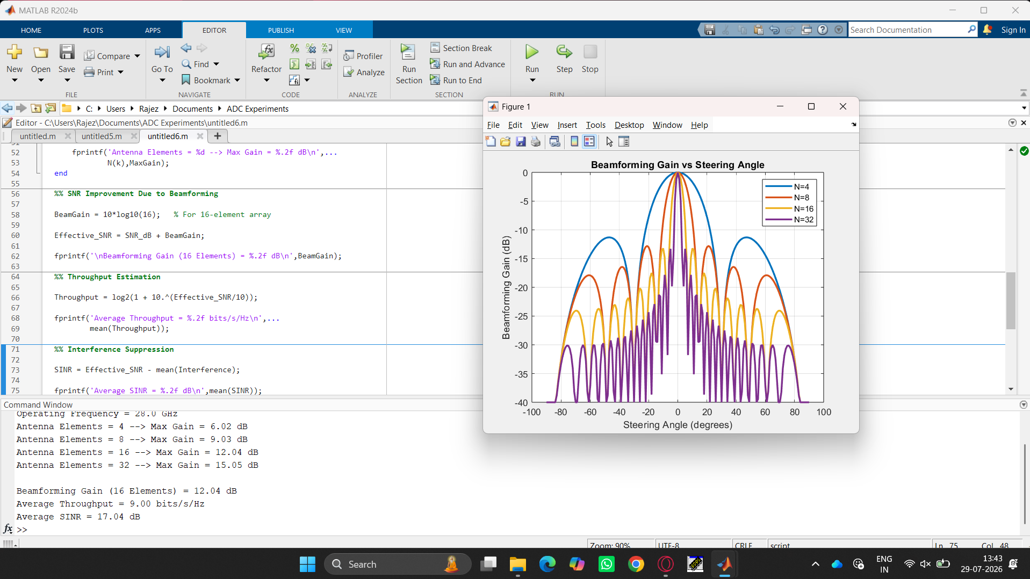

OBSERVATION 4: Simulation of gNodeB traffic handling under user density, latency, throughput, packet loss, and scheduling.
CODING:
clc;
clear;
close all;
%% Simulation Parameters
user_density = 50:50:1000; % Users per cell
%% Scheduling Efficiency (0.7 to 1)
scheduling_eff = 0.7 + 0.3*rand(size(user_density));
%% Latency Model (ms)
latency = 5 + 0.03*user_density ...
- 2*scheduling_eff;
%% Throughput Model (Mbps)
throughput = 1000 .* scheduling_eff ...
./ (1 + user_density/500);
%% Packet Loss (%)
packet_loss = 0.5 + 0.01*user_density ...
- 0.4*scheduling_eff;
packet_loss(packet_loss < 0) = 0;
%% Single Graph: Throughput vs User Density
figure;
plot(user_density,throughput,'b-o','LineWidth',2);
grid on;
xlabel('User Density (Users/Cell)');
ylabel('Throughput (Mbps)');
title('gNodeB Traffic Handling: Throughput vs User Density');
%% Results
fprintf('\n===== gNodeB Traffic Handling Analysis =====\n');
fprintf('Aveage Latency = %.2f ms\n',mean(latency));
fprintf('Average Throughput = %.2f Mbps\n',mean(throughput));
fprintf('Average Packet Loss = %.2f %%\n',mean(packet_loss));
fprintf('Average Scheduling Efficiency = %.2f\n', ...
mean(scheduling_eff));
%% Display Sample Values
disp(' ');
disp('UserDensity Latency(ms) Throughput(Mbps) PacketLoss(%)');
disp([user_density' latency' throughput' packet_loss']);

OUTPUT FOR OBSERVATION 4:
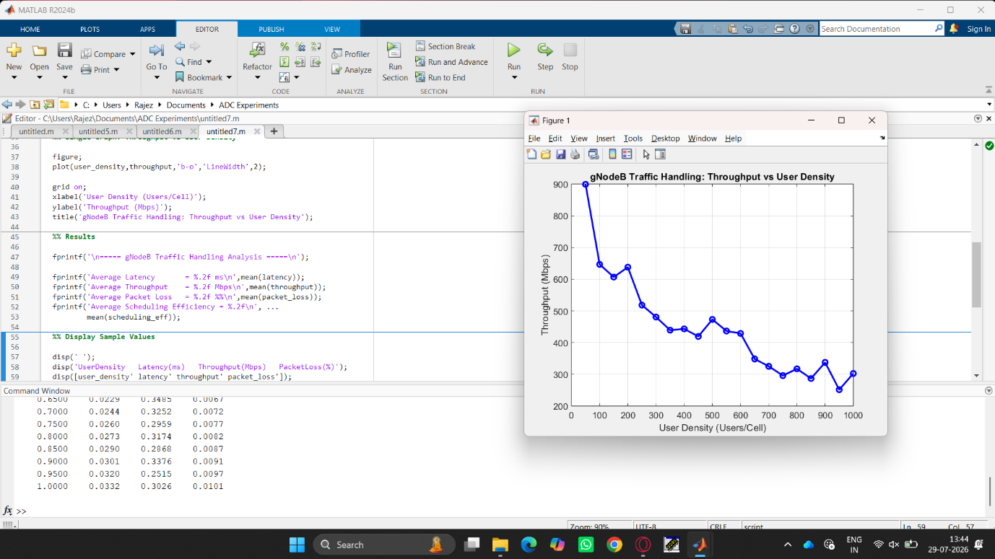

OBSERVATION 5: Simulation of V2X communication under latency, vehicle speed, packet delivery ratio, throughput, and interference.
CODING:
clc;
clear;
close all;
%% Simulation Parameters
vehicle_speed = 10:5:120; % Vehicle Speed (km/h)
%% Latency Model (ms)
latency = 5 + 0.15*vehicle_speed + rand(1,length(vehicle_speed));
%% Interference Level (dB)
interference = 2 + 0.08*vehicle_speed;
%% Packet Delivery Ratio (%)
PDR = 99 - 0.12*vehicle_speed - 0.2*interference;
PDR(PDR < 50) = 50;
%% Throughput Model (Mbps)
throughput = 100 - 0.4*vehicle_speed ...
- 0.5*interference;
throughput(throughput < 5) = 5;
%% Single Graph: PDR vs Vehicle Speed
figure;
plot(vehicle_speed,PDR,'b-o','LineWidth',2);
grid on;
xlabel('Vehicle Speed (km/h)');
ylabel('Packet Delivery Ratio (%)');
title('V2X Communication: PDR vs Vehicle Speed');
%% Results
fprintf('\n===== V2X Communication Analysis =====\n');
fprintf('Average Latency = %.2f ms\n',mean(latency));
fprintf('Average Throughput = %.2f Mbps\n',mean(throughput));
fprintf('Average PDR = %.2f %%\n',mean(PDR));
fprintf('Average Interference = %.2f dB\n',mean(interference));
%% Display Sample Data
disp(' ');
disp('Speed(km/h) Latency(ms) PDR(%%) Throughput(Mbps) Interference(dB)');
disp([vehicle_speed' latency' PDR' throughput' interference']);

OUTPUT FOR OBSERVATION 5:
